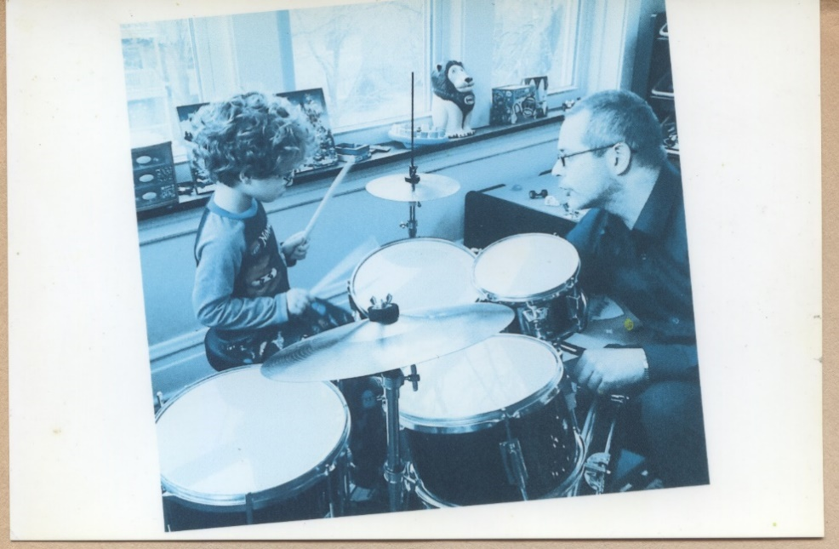
Veteran Jazz drummer Jimmy Bennington now offering lessons.
ZOOM Virtual or In Person Learning
Teaching Objective: I have engaged music students of all ages, skills/abilities, and learning styles these last 30 + years through active participation and creative expression. I do this through enthusiastically bringing the best of my music performing, recording, & training experience to each and every student via ZOOM virtual lessons or In Person lessons. Focus, Coordination, Cognitive Abilities improved are just a few immediate benefits…
Quote: “Once mentored by John Coltrane drummer Elvin Jones, Chicago-based drummer Jimmy Bennington celebrates 30+ years in the music field... Bennington's unique sound and loose drumming, which doesn't follow traditional rhythmic patterns...and leaves quite a bit of room to freedom.” - Down Beat Magazine
Professional Background: As a professional musician for 30+ years, I have served in numerous musical endeavors: performing and recording artist, bandleader, music instructor, workshop clinician, band manager, drum technician, and music reporter/writer (References Upon Request).
Teaching, Service, and Involvement: *Guest Lecturer at the Jazz Forum at University of Illinois (Urbana-Champaign) *Jazz Jamboree Showcase & School Music Seminars (Arlington Hts, IL) * Youth & Family Drum and Rhythm Workshops * Artist Residency for the Children’s Cancer Association (Portland, OR) * Performer/ Clinician at VSA ArtsSpring for youth with learning & developmental delays (Seattle, WA) * Performer for several Not-For-Profit Foundations, Youth Centers, Community Soup Kitchens, etc. * Instructor, Educator, Clinician * Band Leader, Internationally-Recognized Performing and Recording Artist * Former Drum Tech – late John Coltrane drummer Elvin Jones, US/Europe (200-2002) * Jimmy is proudly endorsed by Dream Cymbals and Gongs, Inc.
**Don’t want to Drum, but Do want to support the Arts?
Artist Support and Donations Welcome**
Jimmy Bennington - Drummer/ Bandleader/ Educator
Visit: www.jbcolourandsound.com / Contact: thatswan@gmail.com

